OBJECT ORIENTED PROGRAMMING USING JAVA

NAME : P.R.DHANVIN

DEPT & SEC : CSE & B

ROLL NO: 230701071

WEEK : 2

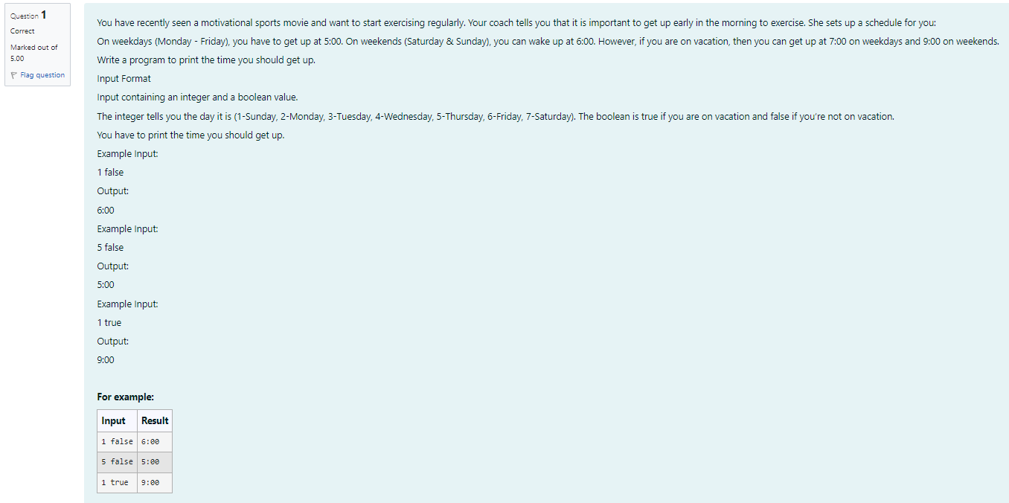

import java.util.Scanner;

public class WakeUpTime {

public static void main(String[] args) {

Scanner scanner = new Scanner(System.in);

int day scanner.nextInt();

boolean onVacation scanner.nextBoolean();

String wakeUp Time;

if (onVacation) {

if (day 1 || day == 7) { wakeUpTime = "9:00"; } else { wakeUpTime = "7:00"; }

} else {

if (day 1 || day == 7) { wakeUpTime = "6:00"; } else { wakeUpTime = "5:00"; }

}

System.out.println(wakeUpTime);

scanner.close();

}

}

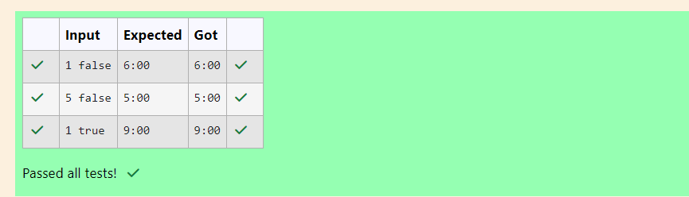

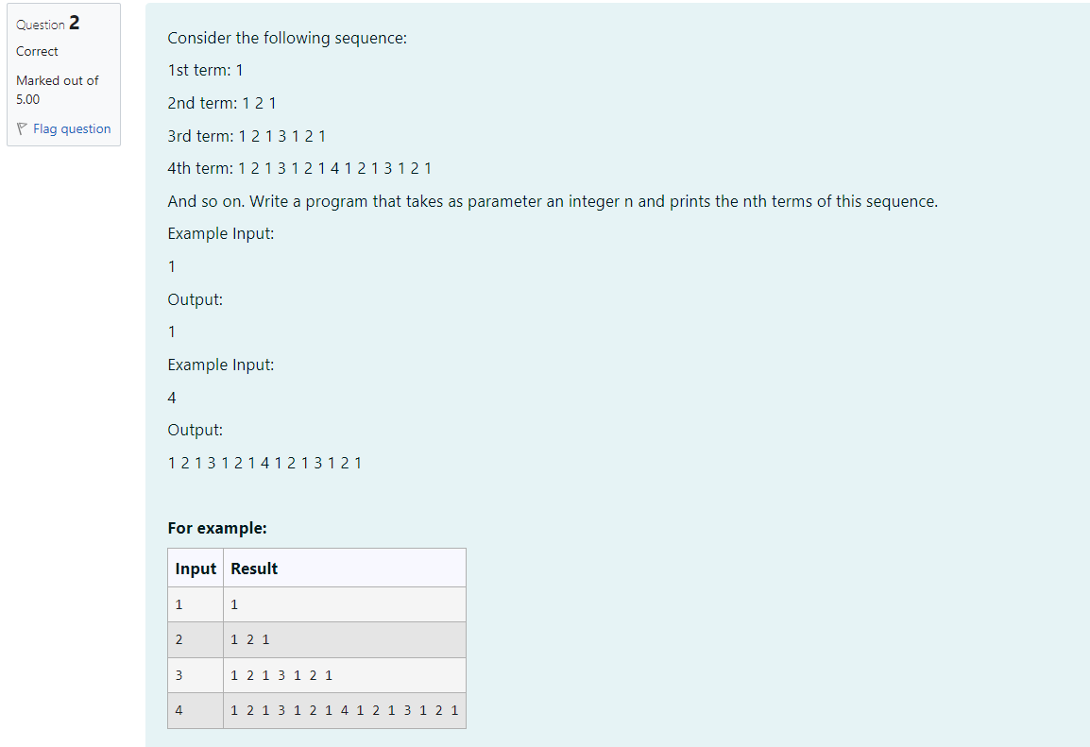

import java.util.Scanner;

public class SequenceGenerator {

public static String generateTerm (int n) {

if (n == 1) {

return "1";

} else {

String previous Term generateTerm(n-1);

return previous Term + + n + " " + previous Term;

}

}

public static void main(String[] args) {

Scanner scanner = new Scanner(System.in);

int n = scanner.nextInt();

System.out.println(generateTerm(n));

scanner.close();

}

}

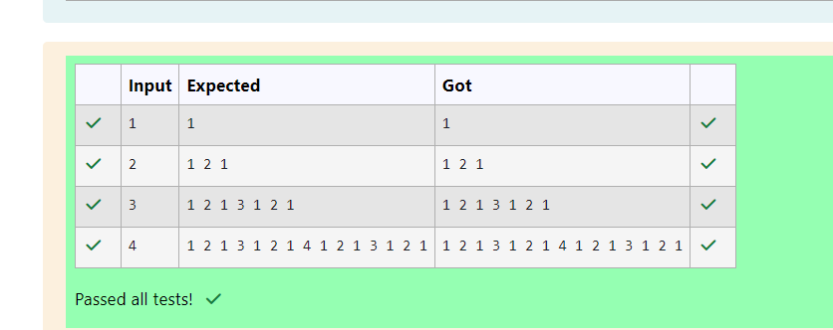

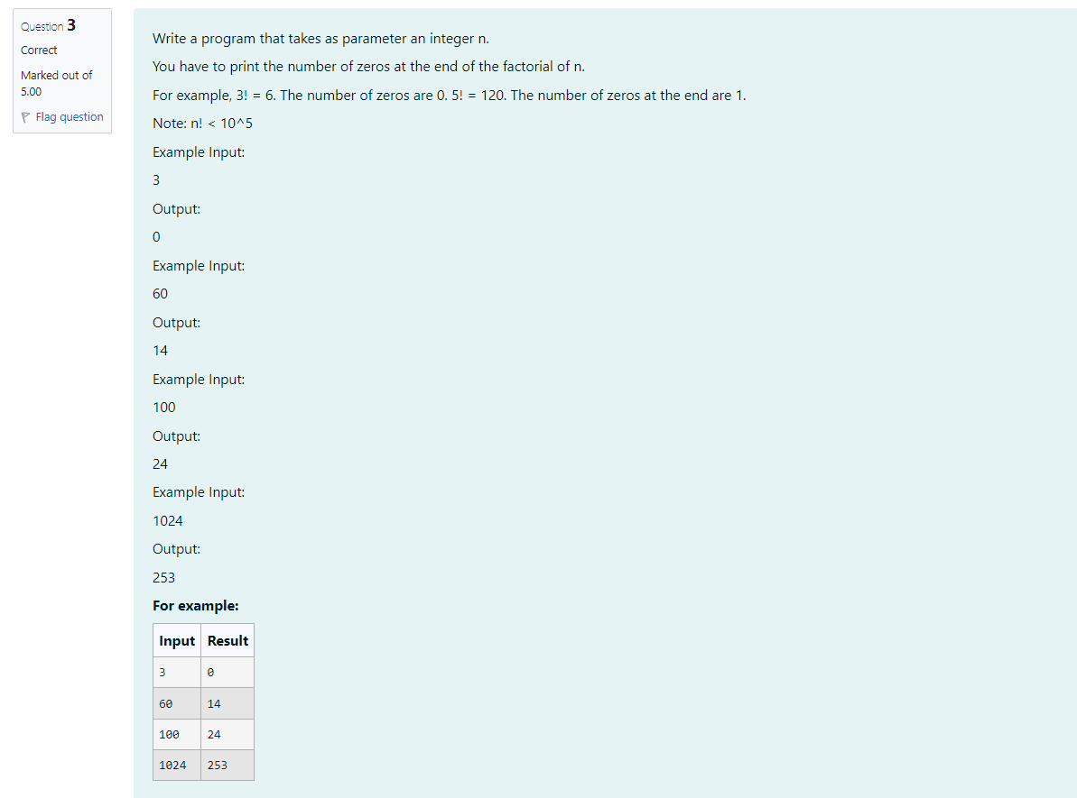

import java.util.Scanner;

public class puttu {

public static int Zeros(int n) {

int count = 0;

for (int i= 5; n/i> 1; 1\*5) {

count += ni;

}

return count;

}

public static void main(String[] args) {

Scanner scanner = new Scanner(System.in);

int n = scanner.nextInt();

int result = Zeros(n);

System.out.println(result);

}

}

